# Bongo SRE Test

Q. Certain web pages are loading slow in user’s browser for our live web application. What

steps will you take to resolve the issue?

Ans: First of all, I will check from my laptop web browser, If I also face same slowness from my laptop, then I will do the diagnosis in following way:

* Will check server health (IOPS, CPU, memory)
* Will check network bottleneck
* Will check underlaying database performance
* Will crosscheck with web site admin for unoptimized images, coding level, caching techniques, gzip compression usability, CDN service

Q. Imagine a scenario where a web application is serving from a single web server to the internet. What are the problems in this scenario? Design and architect a solution that will mitigate these problems? Or How would you design a scalable architecture with resiliency in

mind for the following situations:

a. if a service is resource intensive

b. a service needs to be low latency

c. if parts of a service need to be restricted to certain geographical boundaries

Ans: If any web application is serving from a single web server to the internet, the service will might face below issues:

* Slowness will face as no other server here to share the load
* Impact on service availability as if the server goes down then no service will available.
* Server will face high load average of resources (CPU, memory, IOPS, etc)
* Web contain will be in risk of loose.
* Must required downtime during any upgradation or patching.
* Not easy task when it required to scalable resources.
* Migration required when it required to add another web server.

If I want to reduce above problems, and considering mentioned solutions, high availability architecture will appropriate here. But designing an architecture we have to consider many more points like budget.

Let’s have a simple solution design as per your mentioned points:

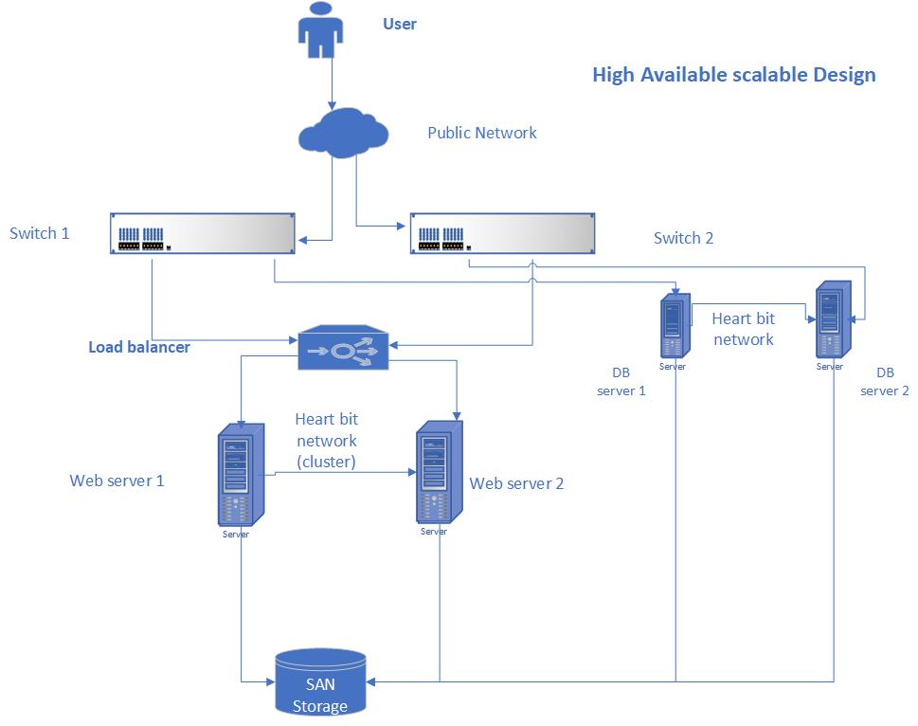

Q. Currently there’s no monitoring in place for the above single web server. How and what

application will you use to monitor the resources/process in your new design?

Ans: There has lots of open source and paid licensed monitoring tool available to monitor. Below is monitoring tool we can use.

* Grafana
* Prometheus
* Graphite
* Cacti
* Oracle EM cloud control

Q. In our server we want to create a user who can only view logs using `less` from this path

/var/log. Please explain how to achieve this.

Ans: I can execute it using sudo. For an example, I am using Redhat OS. And I am creating a normal user name “test”.

From root user: add line “test ALL=(ALL) NOPASSWD: /usr/bin/less /var/log/*” in /etc/sudoers file

vi /etc/sudoers

test ALL=(ALL) NOPASSWD: /usr/bin/less /var/log/*

Now from user test, I can execute less command to any log file in the path “/var/log/”. Just for an example,

su – test

sudo /usr/bin/less /var/log/messages

sudo /usr/bin/less /var/log/maillog

Q. Explain how you can ssh into a private server from the internet.

Ans: port forwarding with NAT is the solution to do this. I can do this using router or server. Just need to configure 2 port (public and private) and add 1 port forwarding rules and 1 NAT rules. That’s it.

Q. Write a bash function that will find all occurrences of an IPv4 from a given file.

Ans: Let’s assume I have a text file named ip.txt which contain all occurrences IP address of IPv4.

So, in bash function I will use below command to find all IP’s,

grep -E -o "(25[0-5]|2[0-4][0-9]|[01]?[0-9][0-9]?)\.(25[0-5]|2[0-4][0-9]|[01]?[0-9][0-9]?)\.(25[0-5]|2[0-4][0-9]|[01]?[0-9][0-9]?)\.(25[0-5]|2[0-4][0-9]|[01]?[0-9][0-9]?)" ip.txt